Problem no 01:
Problem name: Find length of a string using function.
Code:
#include<stdio.h>
int main()
{
char string[100];
int length;
printf("Enter any string:");
gets(string);
length=strlen(string);
printf("Length=%d",length);
return 0;
}
Output:
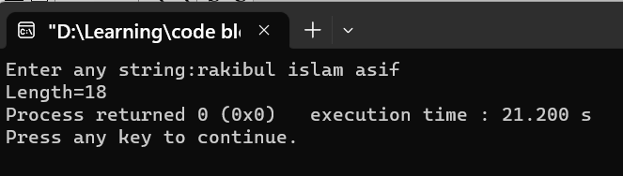

Problem no 02:
Problem name: Find length of a string without using function.
Code:
#include<stdio.h>
int main()
{
char string[100];
int i,count=0;
printf("Enter a string:");
gets(string);
for(i=0;string[i]!='\0';i++)
{
count++;
}
printf("string is:");
puts(string);
printf("Length=%d",count);
return 0;
}
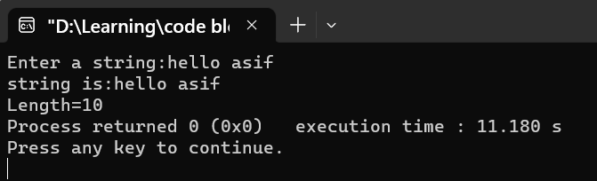
Problem no 03:
Problem name: Write a program to copy one string to another string using function.
Code:
#include<stdio.h>
int main()
{
char name1[100],name2[100];
printf("Enter any name:");
gets(name1);
strcpy(name2,name1);
printf("Original name is:");
puts(name1);
printf("Copy name is:");
puts(name2);
return 0;
}
Output:
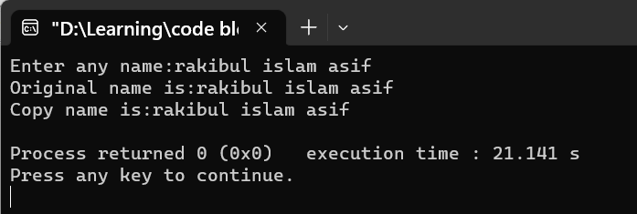
Problem no 04:
Problem name: Write a program to copy one string to another string without function.
Code:
#include<stdio.h>
int main()
{
char name1[100],name2[100];
int copy;
printf("Enter any name:");
gets(name1);
copy=name1;
printf("Original name is:");
puts(name1);
printf("Copy name is:%s\n",copy);
return 0;
}
Output:
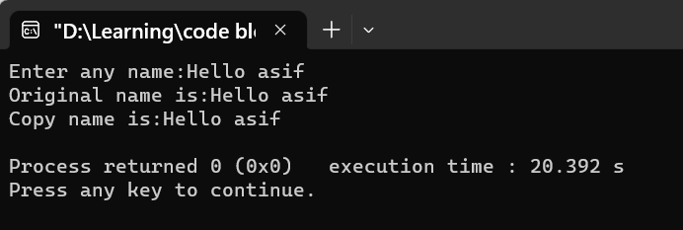
Problem no 05:
Problem name: Write a program to concatenate two string suing function.
Code:
#include<stdio.h>
int main()
{
char asif1[100],asif2[100];
printf("Enter first string:");
gets(asif1);
printf("Enter second string:");
gets(asif2);
strcat(asif1,asif2);
printf("Concatenating string is:");
puts(asif1);
}
Output:
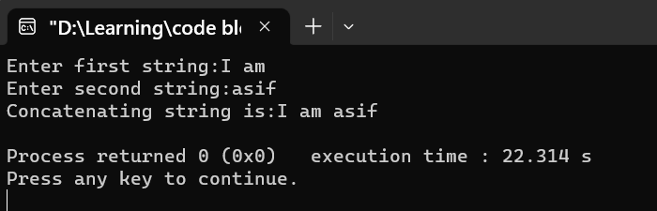

Problem no 06:
Problem name: Write a program to concatenate two string without function.
Code:
#include<stdio.h>
int main()
{
char asif1[100],asif2[100];
int i,j;
printf("Enter first string:");
gets(asif1);
printf("Enter second string:");
gets(asif2);
for(i=0;asif1[i]!='\0';i++)
{

}
for(j=0;asif2[j]!='\0';j++)
{
asif1[i]=asif2[j];
i++;
}
printf("Concatenating string is:%s",asif1);
}
Output:
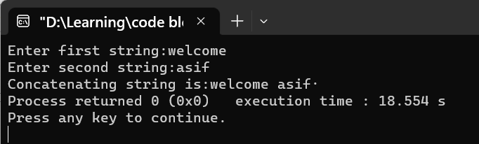

Problem no 07:
Problem name: Write a program to compare two string using function.
Code:
#include<stdio.h>
int main()
{
char string1[100],string2[100];
level:printf("Enter two string:");
gets(string1);
printf("Enter two string:");
gets(string2);
char a;
a=strcmp(string2,string1);
if(a==0)
{
printf("string are equal\n");
}
else if(a<0||a>0)
{
printf("string are not equal\n");
}
goto level;
}
Output:
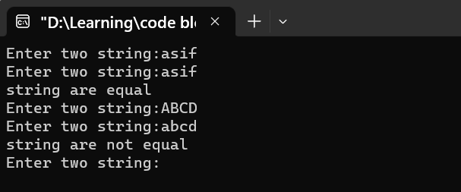

Bangladesh University of Business & Technology



Lab Report: 09
Course Title: Structured Programming Language Lab
Code: CSE-112

Submitted By | Submitted To
Name: Rakibul islam asif  ID:22235103319  Intake:51, Section:8  Department of CSE | Name: Md. Saddam Hossain.  Assistant Professor  Department of CSE BUBT

Submission Date: 06-04-2023

